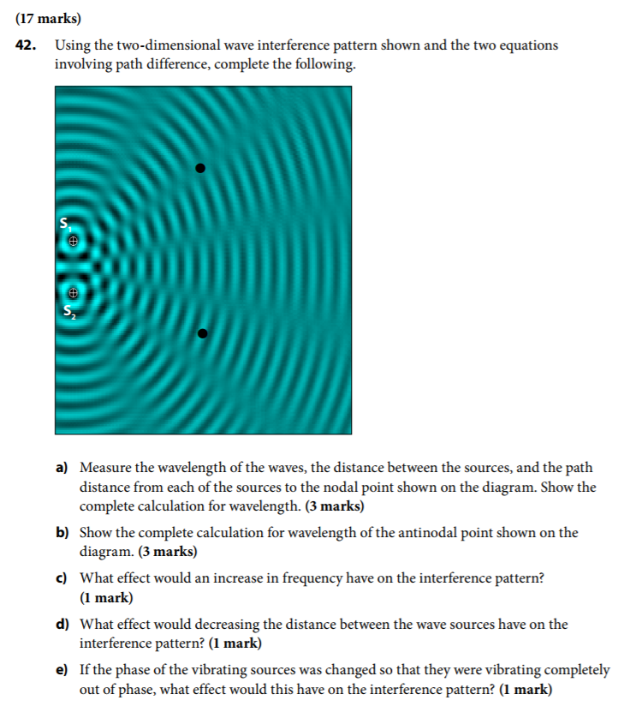

C:\Users\Kai\AppData\Local\Microsoft\Windows\INetCache\Content.Word\chrome_2017-10-18_15-24-06.png

From the investigation conducted earlier in this lesson, I understood that when wave length is constant, frequency and diffraction are inversely proportional of each other. Higher frequency has lower diffraction, while lower frequency has higher. Therefore, if I hear music in the distance, I would be more likely to hear the bass notes of the music due to lower notes having lower frequency and higher diffraction.

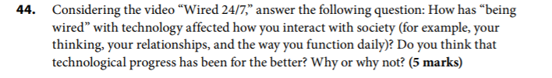

For me, being constantly in contact with technology and information has been mostly beneficial for my life. As a full time student, my studying efforts have been greatly aided by technology. Being constantly in touch with my classmates and professors enables me to learn more efficiently and solve problems faster than before. Technology has been crucial in helping me maintain and develop my romantic relationship as well. With the help of Instant Messengers and webcams, I can speak face-to-face with my girlfriend who lives 500km away in Montreal. Of course, the advancement of information technology has it problems, such as increased stress and over-dependence on technology, but overall I believe the pros outweigh the cons

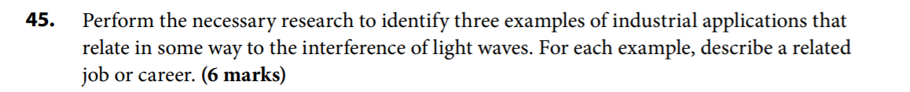

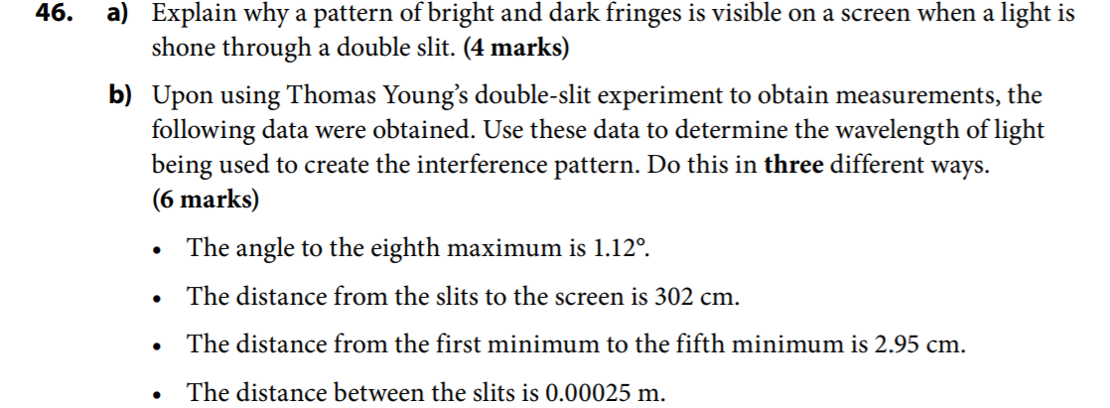

1. When light waves travels through a double slit, they are diffracted and their angles are changed. As a result, interference occurs. During interference , the waves that are in-phase will interefere constructively, creating bright fringes, while the out-of-phase waves will interfere destructively, creating dark fringes.

$$θ_{m}=1.12°$$

$$L=302cm=3.02m$$

$$x_{4}=2.95cm=2.95*{10}^{-2}m$$

$$∆x=\frac{2.95*{10}^{-2}m}{4}=7.375*{10}^{-3}m$$

$$d=0.00025m$$

$$method 1:using relationship involving θ$$

$$mλ=dsin θ_{m}$$

$$m=8$$

$$8λ=0.00025m*\sin{1.12°}$$

$$λ=6.11*{10}^{-7}m$$

$$method 2:using relationship involving ∆x$$

$$∆x=\frac{Lλ}{d}$$

$$7.375*{10}^{-3}m=\frac{\left(3.02m\right)λ}{0.00025m}$$

$$λ=6.11*{10}^{-7}m$$

$$method 3:using relationship involving x_{n}$$

$$x_{n}=x_{m}=0.0295m$$

$$mλ=\frac{dx_{m}}{L}$$

$$4λ=\frac{0.00025m*0.0295m}{3.02m}$$

$$λ=6.11*{10}^{-7}m$$

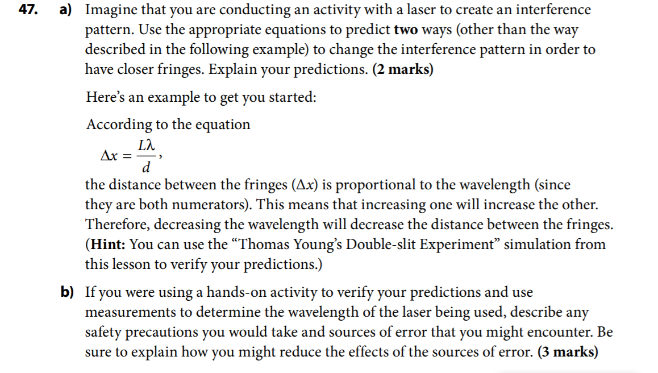

1. According to the equation $∆x=\frac{Lλ}{d}$, $∆x$ is proportional to the distance between the slits and the fringes $(L)$. Therefore, decreasing $L$ will also cause $∆x$ to decrease.

From the same equation, $∆x$ is inversely proportional to the distance between the slits $(d)$. Therefore, increasing $d$ will cause $∆x$ to decrease

1. Precautions: wear goggles to protect my eyes from laser.

Reduce the effect of the sources of error: perform the experiment multiple times and obtain their results. Calculate the outcome using at least 3 different methods I have learned in this lesson, then take the average.

48. Choose a technology such as MP3 players, lasers, medical imaging, or another that interests you (other than the cell phone). Research the Internet and find out how it is related to the physics of light and waves. In approximately 100 to 150 words, write a paragraph explaining the link between our understanding of the laws of physics and your chosen technology. Evaluate how this technology has affected our daily lives. Be sure to briefly describe the technology, its use, and its link to science.

49. A laser emitting light with a wavelength of 560 nm is directed at a single slit, producing an interference pattern on a screen that is 3.0m away. The central maximum is 5.0cm wide.

a. Determine the width of the slit and the distance between adjacent maxima.

$$λ=\frac{w∆y}{L}$$

$$λ=560nm=5.60*{10}^{-7}m$$

$$2∆y=5.0cm, ∆y=2.5cm=2.5*{10}^{-2}m$$

$$L=3.0m$$

$$5.60*{10}^{-7}m=\frac{w*2.5*{10}^{-2}m}{3.0m}$$

$$w=6.7*{10}^{-5}m$$

$$the width of the slit is 6.7*{10}^{-5}m$$

b. What would the effect on this pattern be, if

i. the width of the slit was smaller?

Since the width $(w)$ is inversely proportional to the width of the fringes $(∆y)$. If the width of the slit was smaller, the width of the fringes would increase, resulting in larger diffraction and a larger , less focused pattern.

ii. the screen was moved further away?

Since the distance from the slit to the screen $(L)$ is proportional to the width of the fringes, if the screen was moved further away, the length would be increased, and the width of the fringes would also increase. The result is larger diffraction and a larger, less focused pattern.

iii. a larger wavelength of light was used?

Since the wavelength of light $(λ)$ is proportional to the width of the fringes. If no other factors are changed, a larger wavelength of light would result in wider fringes. The result is larger diffraction and a larger, less focused pattern

1. How would this interference pattern differ if the light was shone through a
   * 1. Double slit?

The fringes would be more evenly distributed, and the pattern would be clearer.

* + 1. Diffraction grating?

The interference pattern would be clearer and more defined

50. Light from a laser with a wavelength of 760nm is directed at a diffraction grating of 1500 lines/cm. If the diffraction grating is located 1.5m from the screen, calculate the distance between adjacent bright fringes.

51. Lenses often contain thin coatings to reduce reflections and UV radiation. Explain how this works.

The coatings (called AR) equalizes the intensity of the lights reflected from the inner and out surfaces. The coating works by shifting the light waves out of phasing and resulting in destructive interference. Since the two reflections from each surface interfere destructives, they will cancel each other out.

As the reflection is cancelled, they emitted energy that is absorbed by the lenses. Therefore, lenses are made of UV radiation absorbing materials that can absorbed the UV emitted onto the lenses

52. Imagine that you had two polarizing films and were holding them one on top of the other. What would the effect of rotating the two polarizing films, with respect to one another, be? Explain what would be seen, and why.

Assuming the polarizing films are identical and in the same alignment. When rotating one film by 90 degrees. No light can pass through the films. That is because the at 90 degrees, the already polarized light encounters a second polarized film, whose polarizers are perpendicular to the polarized waves. When rotating at 180 degrees, the polarizers become aligned again, allowing the polarized light to pass through. When rotating at 270 degrees, the same conditions occurs as 90 degrees, and no light can pass through. Finally, at 360 degrees, Lights pass through the two polarizing films as if they were one.

53. A cell phone sends and receives electromagnetic waves in the microwave frequency range.

a. explain the physics of how an oscillator creates these waves.

b. Research the possible side effects of using cell phones. Citing at least three websites that you consider reliable, write a short 100- to 150-word paragraph summarizing three main conclusions based on your research and your opinions; in other words, will your cell phone usage change, based on what you have learned?